**Assignment -4**

SMS SPAM Classification

|  |  |
| --- | --- |
| Date | 15.11.2022 |
| Team ID | PNT2022TMID30023 |
| Project Name | Emerging Methods For Early Detection Of Forest Fires |
| Team Lead | LOGESH K |
| Team Members | MURALIDN N  VIGNESH K  VIGNESH G |

* **Download the Dataset:** [**- Dataset**](https://www.kaggle.com/code/kredy10/simple-lstm-for-text-classification/data)
* **Import the necessary libraries**

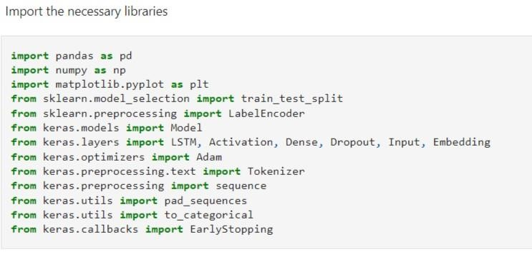

* **Read dataset and do pre-processing**

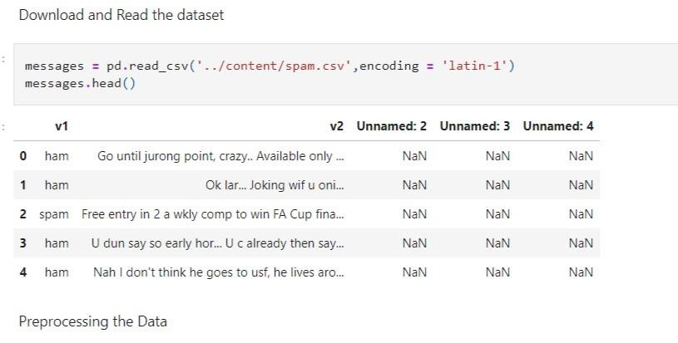

* **Pre-processing the dataset**

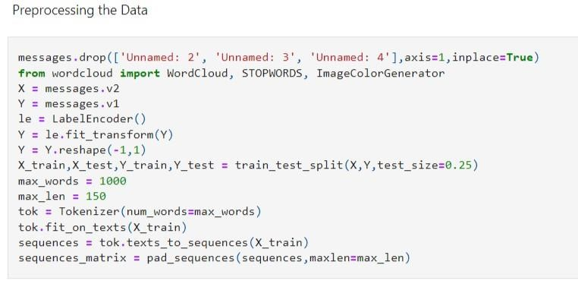

* **Create Model**

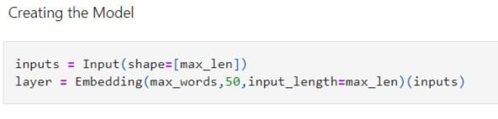

* **Add Layers (LSTM, Dense-(Hidden Layers), Output)**

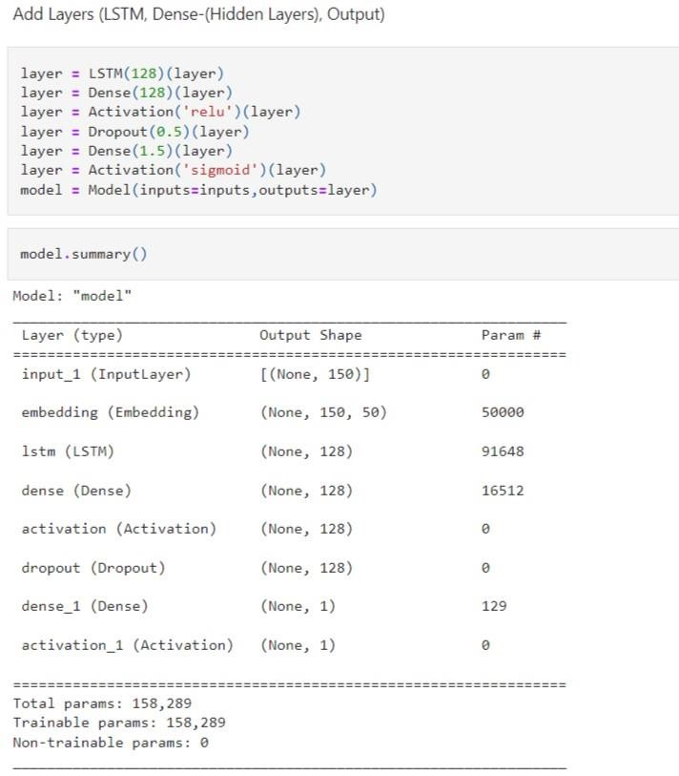

* **Compile the Model**

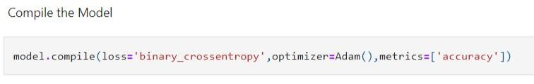

* **Fit the Model**

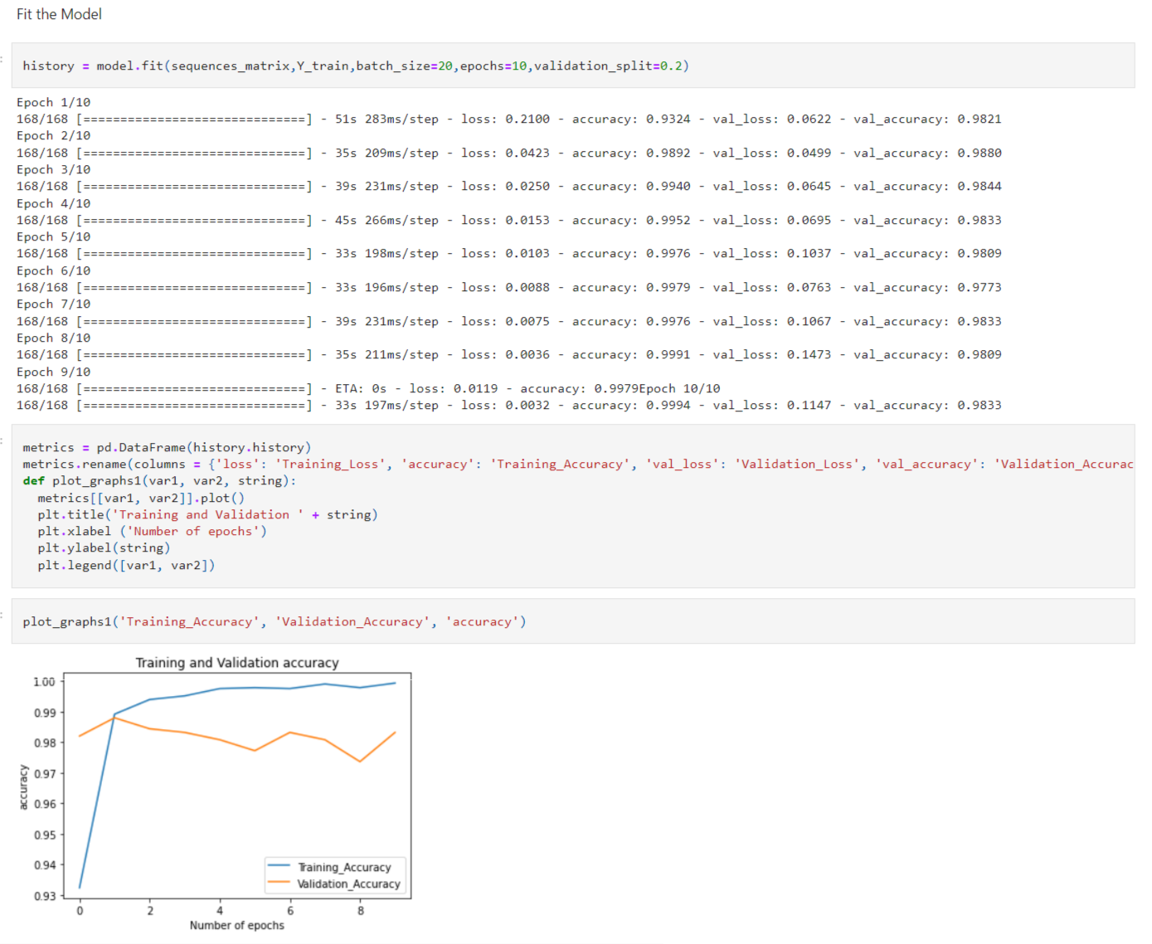

* **Save The Model**

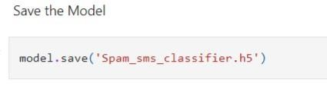

* **Test The Model**

